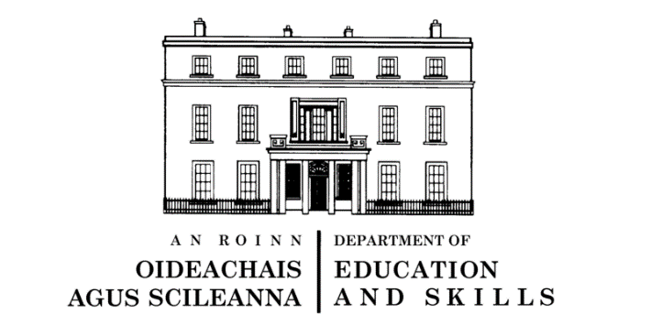

GDPR and Data Protection- Privacy Statement

The General Data Protection Regulation (the GDPR) comes into effect on the 25th May 2018. The GDPR applies across the European Union and aims to give individuals more rights, control and understanding of how their personal data is processed.

Under GDPR the Department of Education and Skills are required to keep you informed of the types of data we hold on you and your child, the purpose it is used for, and your rights in relation to how it is processed.

The Department of Education and Skills, which provides for the education and training of people resident in the State, requires certain personal data on all learners in order to fulfil its function. For primary school pupils, this data is held on the Primary Online Database (POD). The data held on POD forms the basis of the allocation of resources to schools as well as statistical reporting on education; it is also used for research and analysis into the operation of the education system and the formation of future policies. Data is shared with the Department of Employment Affairs and Social Protection for validation purposes, and with the Central Statistics Office under Section 31 of the Statistical Act for statistical reporting and analysis.

The complete Privacy Notice, which outlines further information in relation to the data held by the Department, can be found on the Department’s website at the link below, as can full details of the Department's data protection policy setting out how the Department will use your child’s data, as well as information regarding your child’s rights as a data subject. https://www.education.ie/en/The-Department/Data-Protection/.

If you have any further queries in relation to POD or the data held therein, the POD Helpdesk can be reached at 01 889 2311 or pod@education.gov.ie

