New Ross Educate Together National School

Barrett’s Park, New Ross, Co. Wexford
Tel: 0539105070
office@newrossetns.ie
www.newrossetns.ie
Roll no 20458m

Healthy Eating Policy

Contents
School Details: 3
Introductory Statement & Rationale 4
Healthy Eating in New Ross Educate Together NS 4
Suitable Drinks for Children 5
Foods Not Permitted 5
Allergies 6
Rewards and Other Exceptions to the Policy above 6
Education Measures 7
Resources 7
Other Tips and Hints 7
Whole School Approach 7
Ratification and Review 7

School Details:

Name: New Ross Educate Together National School
Address: Barrett's Park, New Ross, Co. Wexford.
Telephone: 0539105070
Email: office@newrossetns.ie
Roll Number: 20458m
Principal: Elaine French

The school day starts at 8.30 and finishes at 1.10 for infant classes and 2.10 for all other classes.

Introductory Statement & Rationale

The aim of this Healthy Eating Policy is to help our school community, children, staff and parents develop positive and responsible attitudes to food and nutrition and to appreciate the benefits that healthy food and drink habits make to overall health and wellbeing.

In conjunction with the curriculum subjects SPHE (Social, Personal and Health Education), Science and the Learn Together Programme, we aim to promote nutrition awareness and positively effect healthy food and drink choices within the school community.

Healthy Eating in New Ross Educate Together NS

- The Food Pyramid is the key tool to communicate healthy eating messages.

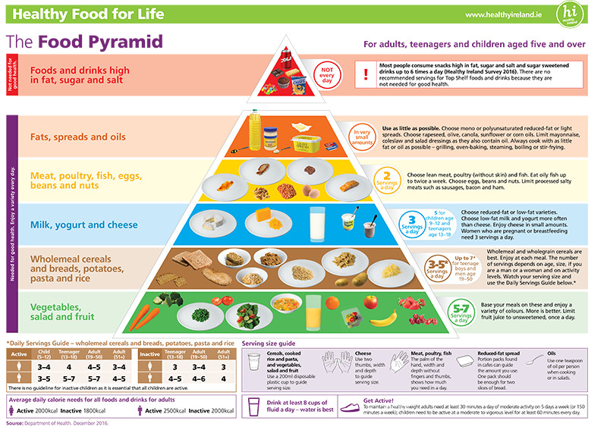

- It is very important for children’s energy and concentration levels that they eat a healthy breakfast before coming to school.
- A healthy lunchbox includes a piece of food from each of the first four shelves of the food pyramid.
- Bottom shelf fruit and vegetables (vitamin/mineral rich) and carbohydrates (energy) are especially encouraged (to ensure recommended daily portions are met).
- Children are encouraged to drink water throughout the day during class time in a non-spill nipple top bottle.
- Children will normally have two food breaks during the day and will be given adequate time to eat.
- Food from shelves 1-4 are actively encouraged during school hours and after school classes held on site.
- Children may, however, bring an item from the top shelf of the pyramid on Fridays (see chart below), or on the last day of term or on a school tour.
- In the interest of fairness and for allergy or religious (as well as health) reasons, cakes, buns or treats (sweets and chocolate) for birthday celebrations are discouraged.
- In the interest of fairness, it is also requested that invitations for birthday parties or other celebrations that occur outside of school hours are distributed outside of the school day.
- We encourage reusable airtight lunch containers and all waste materials are brought home.
- Due to health and safety reasons, lunches cannot be reheated.

Examples of top shelf foods that may be included on Fridays:

Croissant | Small bun | Fruit Winders
Flapjack | Small cereal bar
Plain biscuit | Fun-size bar

Examples of healthier treats:

Extra piece of fruit | Plain rice cakes | Sugar-free jelly pots
Washed, raw vegetable pieces | Crispbreads | Natural or low-fat yoghurt
Plain breadsticks | Unsalted crackers | Pot of custard or rice pudding

Suitable Drinks for Children

- Drinks should always be included in a packed lunch. Extra water should be included on PE days and in warmer weather.
- Water and milk are the most suitable drinks for children.
- Unsweetened fruit juices, “tooth kind” drinks, flavoured milks, smoothies, yoghurt drinks and “no added sugar” dilutable squash should be consumed with meals to help prevent dental health problems.

Foods Not Permitted

In order to ensure children can concentrate fully in class and to ensure the health and safety of children in the school, the following food/drink items are not permitted.

- Fizzy (carbonated) drinks
- Drinks containing stimulants, e.g. energy drinks, coffee
- Any drinks in glass bottles
- Bags of sweets
- Full size bars of Chocolate (fun-size/snack-size is acceptable for an occasional treat)
- Bags of crisps
- Chewing / Bubble gum
- Full size packets of Biscuits (2/3 individually wrapped biscuits or individual snack size packets are acceptable for an occasional treat)
- Sweets that are a choking risk, e.g. gobstoppers, lollipops, etc.

Allergies
In order to protect children with allergies, the school must enforce the banning of certain food items.
- For health and safety reasons, peanuts, peanut based spreads, chocolate spreads and Nutella are not allowed at any time.

Children who bring these items into school will be asked to leave them in their schoolbags to bring home. Items will not be taken by a teacher permanently but may be confiscated until the end of the school day. However, it is the child’s responsibility to remember to bring home any item that has been confiscated.

Rewards and Other Exceptions to the Policy above

Staff will not give children sweets or chocolate as a reward, in general. However, occasionally treats may be given in school at the teacher's discretion depending on individual behaviour plans, special educational needs, etc. In these situations, parents will be involved in the planning. The teacher will exercise subtlety when rewarding children as younger children may not understand the nature of these exceptions.
Occasionally, the teacher will hold a class party in their classroom. As these situations are not a regular occurrence in classes, an exception is made to the policy. However, children will be encouraged not to bring in an excessive amount of banned foods.
After school clubs are not covered by this policy as they are a choice made by individual families. Therefore, the school does not take any responsibility for any banned items being given in these classes.
The school may host events through its staff, parents’ association and student council. Many of these events will may offer biscuits, cakes, etc. to attendees. There are also some other events that may take place, e.g. Cake Sales, where food from the banned items may be served. Again, as these events are not regular occurrences, they are exceptions to the policy.

Education Measures

- Within SPHE, Science and/or the Learn Together programme, all children will receive appropriate lessons on healthy eating.
- Parents / carers of incoming Junior Infant children and new children to the school will be informed about the Healthy Eating Policy and the policy made available on the school website.

Resources

- www.safefood.eu
- www.healthpromotion.ie/health/healthy_eating
- www.enjoyhealthyeating.info/

Other Tips and Hints

- Keep lunches in fridge if made the night before
- Use a small insulated cool bag especially in warmer weather
- Cut sandwiches into small manageable portions especially for younger children
- Peel fruit for younger children
- Avoid items that children cannot eat without assistance
- Try to give a variety of foods
- Vary the types of bread (wholemeal, granary, high fibre rolls, bagels, pitta and sliced bread)

Whole School Approach

- We appreciate that encouraging children to choose certain foods is not always easy. However, with the increase in obesity, type 2 diabetes and the prevalence of dental caries, we are encouraging best practice especially during school hours. For this policy to be successful, we need support from the whole school community.

Ratification and Review
This policy was ratiﬁed by the Board of Management on the 24/1/2019. It is scheduled for review in 2021.
This policy has been made available to school personnel, published on the school website and provided to the Parent-Teacher Association. A copy of this policy will be made available to the Department of Education and Skills and the Patron, if requested. Hard copies of this, and all school policies, are available at the school on request.
This policy and its implementation will be reviewed by the Board of Management once in every school year. Written notification that the review has been completed will be made available to school personnel, published on the school website and provided to the Parents Association. A record of the review and its outcome will be made available, if requested, to the patron and the Department.

Signed: ____________________________ Signed: _________
(Principal) (Chairperson, Board of Management)
Date: ___24/1/2019__________

